**Title: Install and demonstrate Splunk for log analysis**

**Objective:**

The objective of this experiment is to install and demonstrate the usage of Splunk, a log analysis and monitoring platform, for efficient log analysis and gaining insights from log data.

**Requirements:**

Splunk installer

**Procedure/Experiment Steps:**

1. Download Splunk: Visit the official Splunk website and download the appropriate installation package for your operating system.
2. Install Splunk: Follow the provided instructions to install Splunk on your computer.

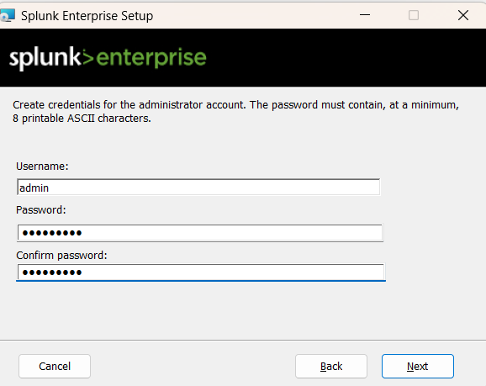

1. Launch Splunk: After installation, launch Splunk from the installed location or desktop shortcut or just go to http://localhost:8000.
2. Set up Splunk: During the initial setup, create an administrator account and configure basic settings.

`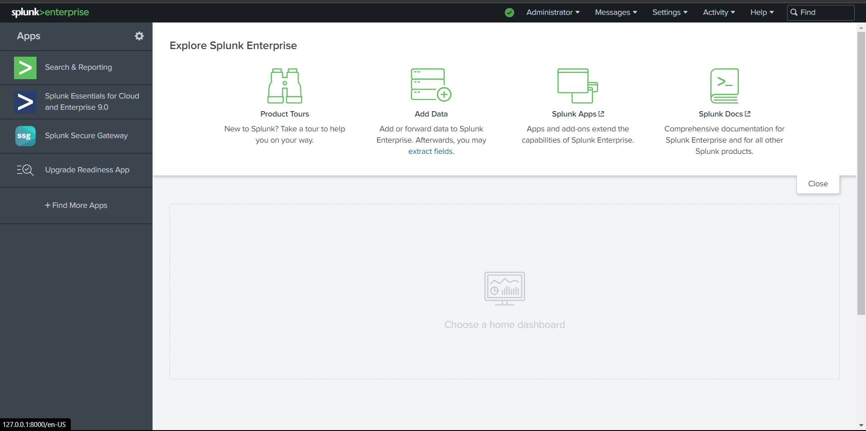

1. Configure data inputs: Set up data inputs to ingest log data from various sources such as log files, network devices, or cloud platforms.

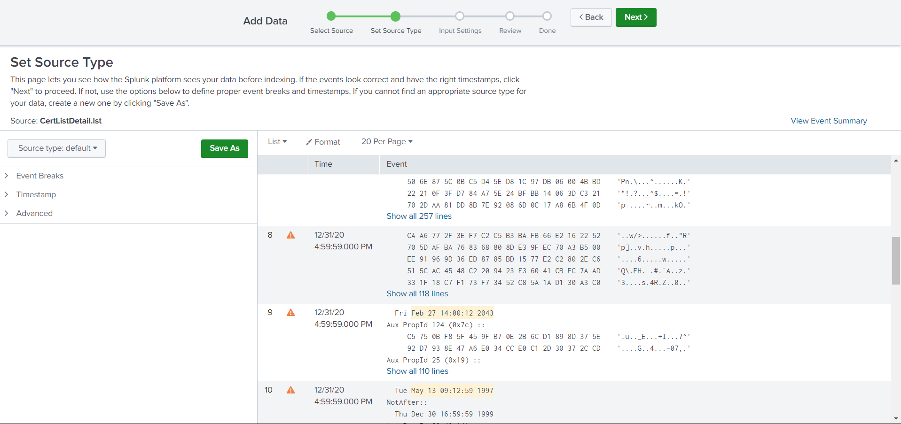

1. Index log data: Create and configure indexes to organize log data efficiently.
2. Search and analyze logs: Utilize Splunk's Search Processing Language (SPL) to search and analyze log data, troubleshoot issues, and extract insights.
3. Create visualizations and reports: Generate visualizations and reports to present log data in charts, graphs, and dashboards.
4. Demonstrate log analysis: Use real or simulated log data to showcase the effectiveness of Splunk in log analysis, anomaly detection, and troubleshooting.

**Result:**

By following the installation and demonstration steps, Splunk was successfully installed and utilized for log analysis. Log data from various sources was ingested and indexed, allowing for efficient searching and analysis. Splunk's search capabilities and visualizations provided valuable insights into the log data, enabling effective troubleshooting and decision-making.

**Conclusion:**

Splunk is a powerful log analysis and monitoring tool that simplifies log management and analysis processes. Its features, including data ingestion, searching, and visualization, allow for efficient log analysis and troubleshooting. By utilizing Splunk, organizations can enhance their log management practices, improve operational efficiency, and gain valuable insights from log data.

**Future Scope:**

1. Integration with additional data sources such as cloud platforms, IoT devices, or specific application logs.
2. Exploring advanced analytics and machine learning capabilities within Splunk for deeper insights and automation of log analysis processes.
3. Utilizing Splunk's security features for robust security monitoring, threat detection, and compliance reporting.
4. Leveraging collaboration features to facilitate knowledge sharing, teamwork, and reporting among different stakeholders.
5. Optimizing Splunk deployment for scalability and performance as log data volume increases, including distributed architecture and performance tuning techniques.